Process Creation Starting New Processes
We can cause a program to run from inside another program and thereby create a new process by using the system. library function.
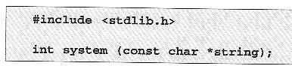

The system function runs the command passed to it as string and waits for it to complete. The command is executed as if the command,

has been given to a shell.

Try It Out - system

- We can use system to write a program to run ps for us.

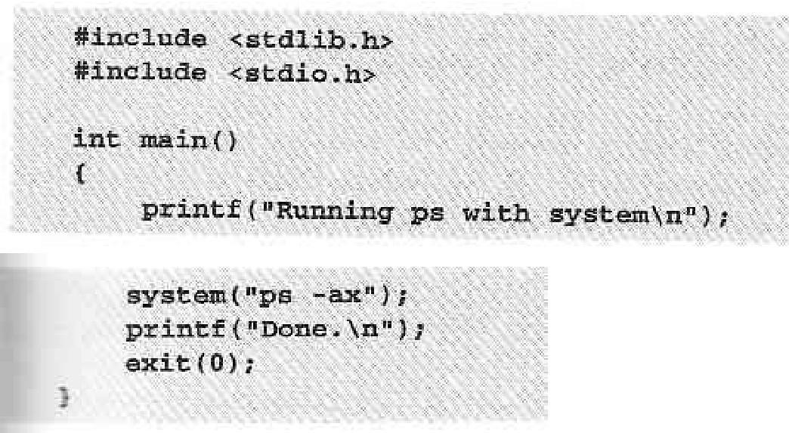

- When we compile and run this program, system.c, we get the following:

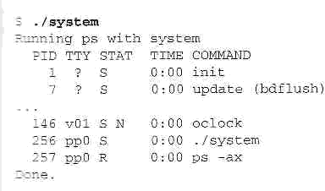

- The system function uses a shell to start the desired program.

We could put the task in the background, by changing the function call to the following:

Now, when we compile and run this version of the program, we get:
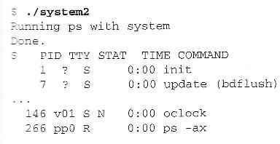

How It Works

In the first example, the program calls system with the string "ps -ax", which executes
the ps program. Our program returns from the call to system when the ps command is finished.

In the second example, the call to system returns as soon as the shell command finishes. The shell returns as soon as the ps program is started, just as would happen if we had typed,

at a shell prompt.

Replacing a Process Image

There is a whole family of related functions grouped under the exec heading. They differ in the way that they start processes and present program arguments.
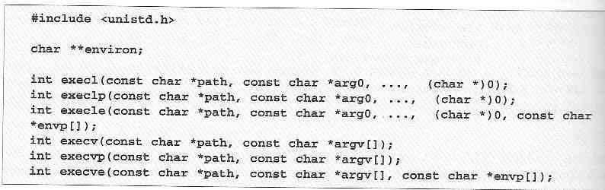
The exec family of functions replace the current process with another created according to the arguments given.

If we wish to use an exec function to start the ps program as in our previous examples, we have the following choices:
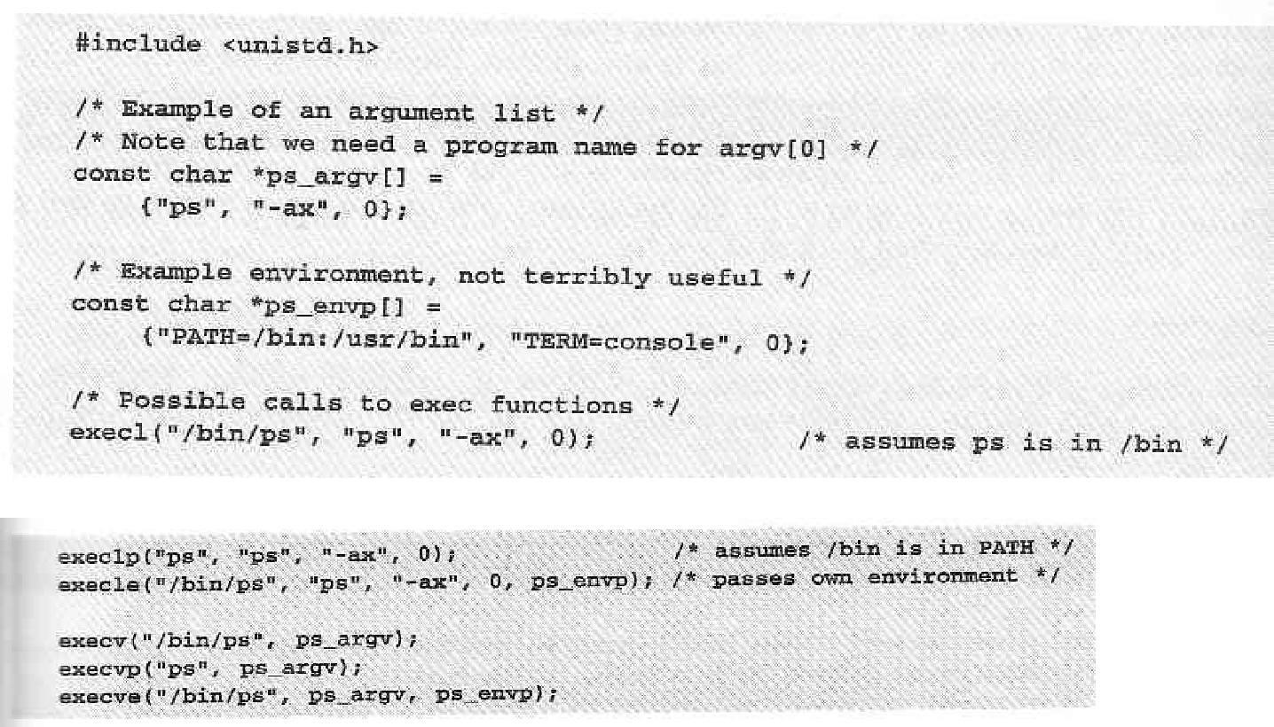

Try It Out - exclp

Let's modify our example to use an exexlp call.

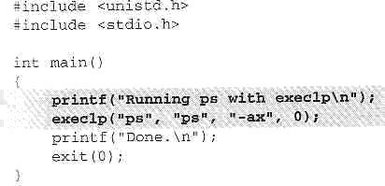

Now, when we run this program, pexec.c, we get the usual ps output, but no Done. message at all.

Note also that there is no reference to a process called pexec in the output:
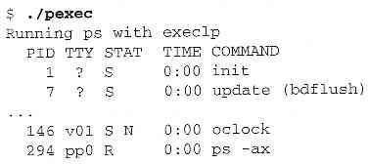

How It Works

The program prints its first message and then calls execlp, which searches the directories given by the PATH environment variable for a program called ps.

It then executes this program in place of our pexec program, starting it as if we had given the shell command:

Waiting for a Process

We can arrange for the parent process to wait until the child finishes before continuing by calling wait.

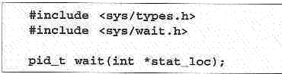

The wait system call causes a parent process to pause until one of its child processes dies or is stopped.

We can interrogate the status information using macros defined in sys/wait.h. These include:
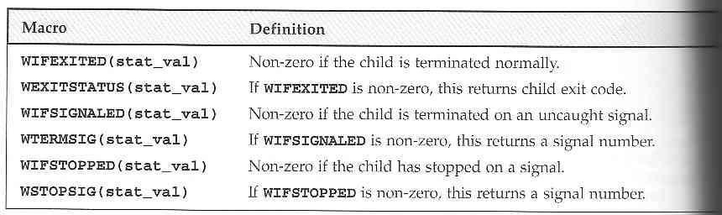

Try It Out - wait

- Let's modify our program slightly so we can wait for and examine the child process exit status. Call the new program wait.c.

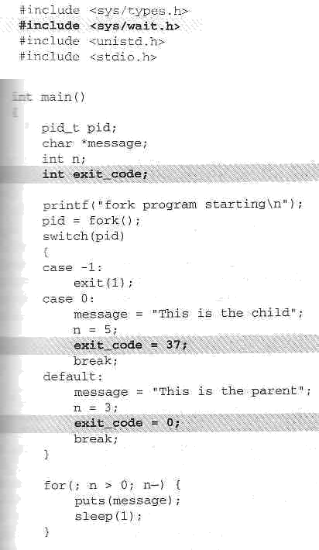

- This section of the program waits for the child process to finish:

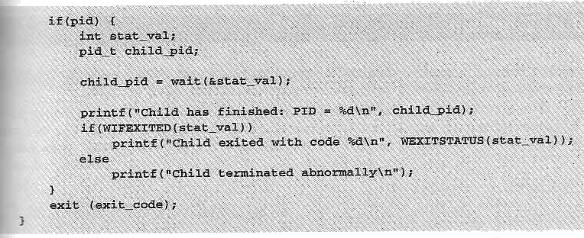

When we run this program, we see the parent wait for the child. The output isn't confused and the exit code is reported as expected.
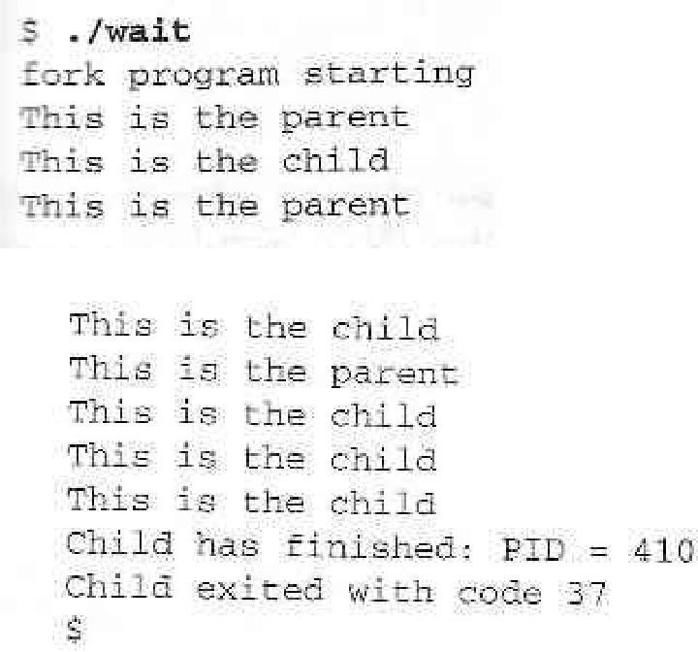

How It Works

The parent process uses the wait system call to suspend its own execution until status information becomes available for a child process.

Zombie Processes

When a child process terminates, an association with its parent survives until the parent in turn either terminates normally or calls wait.

This terminated child process is known as a zombie process.

Try It Out - Zombies

fork2.c is jsut the same as fork.c, except that the number of messages printed by the child and paent porcesses is reversed.

Here are the relevant lines of code:
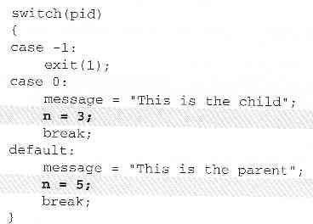

How It Works

If we run the above program with fork2 & and then call the ps program after the child has finished but before the parent has finished, we'll see a line like this:
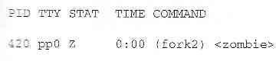
There's another system call that you can use to wail for child processes. It's called waitpid and youu can use it to wait for a specific process to terminate.

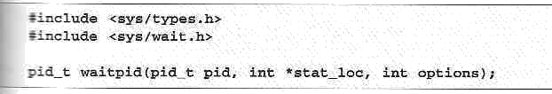

If we want to have a parent process regularly check whether a specific child process had terminated, we could use the call,
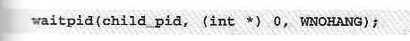
which will return zero if the child has not terminated or stopped or child_pid if it has.

Orphan Process

- When the parent dies first the child becomes Orphan .
- The kernel clears the process table slot for the parent.

System call interface for process management

In addition to the process ID, there are other identifiers for every process. The following functions return these identifiers
#incldue<sys/types.h> #include<unistd.h>
pid_t getpid(void); Returns: process ID of calling process

pid_t geppid(void); Returns: parent process ID OF calling process

uid_t getuid(void); Returns: real user ID of calling process uid_t geteuid(void); Returns: effective user ID of calling process gid_t getgid(void); Returns: real group ID of calling process
gid_t getegid(void); Returns: effective group ID of calling process

fork Function

The only way a new process is created by the UNIX kernel is when an existing process calls the fork function.
#include<sys/types.h> #include<unistd.h> pid_t fork(void);
Return: 0 is child, process ID of child in parent, -1 on error

The new process created by fork is called child process. This is called once, but return twice that is the return value in the child is 0, while the return value in the parent is the process ID of the new child. The reason the child’s process ID is returned to the parent is because a process can have more than one child, so there is no function that allows a process to obtain the process IDs of its children. The reason fork return 0 to the child is because a process can have only a single parent, so that child can always call getppid to obtain the process ID of its parent.
Both the child and parent contain executing with the instruction that follows the call to fork. The child is copy of the parent. For example, the child gets a copy of the parent’s data space, heap and stack. This is a copy for the child the parent and children don’t share these portions of memory. Often the parent and child share the text segment, if it is read-only.
There are two users for fork:

  - When a process wants to duplicate itself so that the parent and child can each execute different sections of code at the same time. This is common for network servers_ the parent waits for a service requests from a client. When the request arrives, the parent calls fork and lets the child handle the request. The parent goes back to waiting for the next service request to arrive.
When a process wants to execute a different program, this is common for shells. In this case the child does an exec right after it returns from the fork.

vfork Function

The function vfork has the same calling sequence and share return values as fork. But the semantics of the two functions differ. vfork is intended to create a new process when the purpose of the new process is to exec a new program. vfork creates the new process, just like fork, without fully copying the address space of the parent into the child, since the child won’t reference the address space – the child just calls exec right after the vfork. Instead, while the child is running, until it calls either exec or exit, the child runs in the address space of the parent. This optimization provides an efficiency gain on some paged virtual memory implementations of UNIX.
Another difference between the two functions is that vfork guarantees that the child runs first, until the parent resumes.

exit Function

There are three ways for a process to terminate normally, and two forms of abnormal termination.
- Normal termination:
  - Executing a return from the main function. This is equivalent to calling exit
  - Calling the exit function
  - Calling the _exit function
- Abnormal termination
  - Calling abort: It generates the SIGABRT signal
  - When the process receives certain signals. The signal can be generated by the process itself
Regardless of how a process terminates, the same code in the kernel is eventually executed. This kernel code closes all the open descriptors for the process, releases the memory that it was using, and the like.

For any of the preceding cases we want the terminating process to be able to notify its parent how it terminated. For the exit and _exit functions this is done by passing an exit status as the argument to these two functions. In the case of an abnormal termination however, the kernel generates a termination status to indicate the reason for the abnormal termination. In any case, the parent of the process can obtain the termination status from either the wait or waitpid

function.The exit status is converted into a termination status by the kernel when _exit is finally called. If the child terminated normally, then the parent can obtain the exit status of the child.

If the parent terminates before the child, then init process becomes the parent process of any process, whose parent terminates; that is the process has been inherited by init. Whenever a process terminates the kernel goes through all active processes to see if the terminating process is the parent of any process that still exists. If so, the parent process ID of the still existing process is changed to be 1 to assume that every process has a parent process.
When a child terminates before the parent, and if the child completely disappeared, the parent wouldn’t be able to fetch its termination status, when the parent is ready to seek if the child had terminated. But parent get this information by calling wait and waitpid, which is maintained by the kernel.

wait and waitpid Functions

When a process terminates, either normally or abnormally, the parent is notified by the kernel sending the parent SIGCHLD signal. Since the termination of a child is an asynchronous event, this signal is the asynchronous notification from the kernel to the parent. The default action for this signal is to be ignored. A parent may want for one of its children to terminate and then accept it child’s termination code by executing wait.
A process that calls wait and waitpid can

- block (if all of its children are still running).
- return immediately with termination status of a child ( if a child has terminated and is waiting for its termination status to be fetched) or
- return immediately with an error (if it down have any child process).

If the process is calling wait because it received SIGCHLD signal, we expect wait to return immediately. But, if we call it at any random point in time, it can block.
#include<sys/types.h> #include<sys/wait.h>

pid_t wait(int *statloc);

pid_t waitpid(pid_t pid, int *statloc, int options); Both return: process ID if OK, o or -1 on error The difference between these two functions is
- wait can block the caller until a child process terminates, while waitpid has an option that prevents it from blocking.
- waitpid does not wait for the first child to terminate, it has a number of options that control which process it waits for.
If a child has already terminated and is a zombie, wait returns immediately with that child’s status. Otherwise, it blocks the caller until a child terminates: if the caller blocks and has multiple children, wait returns when one terminates, we can know this process by PID return by the function.
For both functions, the argument statloc is pointer to an integer. If this argument is not a null pointer, the termination status of the terminated process is stored in the location pointed to by the argument.
If we have more than one child, wait returns on termination of any of the children. A function that waits for a specific process is waitpid function.
The interpretation of the pid argument for waitpid depends on its value:

pid == -1 waits for any child process. Here, waitpid is equivalent to wait pid > 0 waits for the child whose process ID equals pid
pid == 0 waits for any child whose process group ID equals that of the calling process
pid < -1 waits for any child whose process group ID equals the absolute value of pid
waitpid returns the process ID of the child that terminated, and its termination status is returned through statloc. With wait the only error is if the calling process has no children. With waitpid

however, it’s also possible to get an error if the specified process or process group does not exist or is not a child of the calling process.

The options argument lets us further control the operation of waitpid. This argument is either 0 or is constructed from the bitwise OR of the following constants.
WNOHANG waitpid will not blink if a child specified by pid is not immediately
available. In this case, the return value is 0.

WUNTRACED if the status of any child specified by pid that has stopped, and whose status has not been updated since it has stopped, is returned
The waitpid function provides these features that are not provided by the wait function are:

- waitpid lets us to wait for one particular process
- waitpid provides a non-blocking version of wait
- waitpid supports job control (wit the WUNTRACED option)

exec Function

The fork function can create a new process that then causes another program to be executed by calling one of the exec functions. When a process calls one of the exec functions, that process is completely replaced by the new program and the new program starts executing at its main function. The process ID doesn’t change across an exec because a new process is not created. exec merely replaces the current process with a brand new program from disk.
There are six different exec functions. These six functions round out the UNIX control primitives. With fork we can create new processes, and with the exec functions we can initiate new programs. The exit function and the two wait functions handle termination and waiting for termination. These are the only process control primitives we need.
#include<unistd.h>

int execl(const char *pathname, const char *arg0, . . . /*(char *) 0*/ int execv(const char *pathname, char *const argv[]);
int execle(const char *pathname, const char *arg0, . . . /* (char *) 0, char envp[]*/);

int execve(const char *pathname, char *const argv[], char *const envp[]); int execlp(const char *pathname, const char *arg0, . . . /* (char *) 0*/); int execvp(const char *filename, char *const argv[]);
All six returns: -1 on error, no return on success.

The first difference in these functions is that the first four take a pathname argument, while the last two take a filename argument. When a filename argument is specified:
- if filename contains a slash, it is taken as a pathname.
- Otherwise, the executable file is a searched for in directories specified by the PATH environment variable.
The PATH variable contains a list of directories (called path prefixes) that are separated by colors. For example, the name=value environment string
PATH=/bin:/usr/bin:usr/local/bin/:.

Specifies four directories to search, where last one is current working directory.

If either of the two functions, execlp or execvp finds an executable file using one of the path prefixes, but the file is not a machine executable that was generated by the link editor, it assumes the file is a shell script and tries to invoke /bin/sh with filename as input to the shell.

The next difference concerns the passing of argument list. The function execl, execlp and execle require each of the command-line arguments to the new program to be specified as separate arguments. The end of the argument should be a null pointer. For the other three functions execv, execvp and execve, we have to build an array of pointers to the arguments, and the address of this array is the argument to these three functions.

The final difference is the passing of the environment list to the new program. The two functions execle and execve allow us to pass a pointer to an array of pointer to an array of pointer to an array of pointers to the environment strings. The other four functions, however, use the environ variable in the calling process to copy the existing environment for the new program.

